**Name: Saad Rehman  
Student ID: 21F-9640  
Section: 3A**  
**Degree: BS-CS  
Teacher Name: Sir Abdul Qadeer Bilal  
Course: EL-2003 (COAL)  
Lab Number: 05  
……………………………………………………………………………………………………………**

**OBJECTIVES**

**Note: Perform each Question on AFD Debugger.**

**Qno.1**

[org 0x0100]

jmp start

data: dw 10, 9, 3, 50, 20, 40, 60, 70, 30, 80

start:

mov cx, 10 ; loop that runs for 10 times

outerloop:

mov bx,0 ; initialize array index to zero

innerloop:

mov ax,[data+bx] ; load number in ax

cmp ax, [data+bx+2] ; compare with next number

jbe noswap ; no swap if already in order

mov [data+bx+2], dx ;Below 3 lines are for sorting in descending order

mov ax, [data+bx+2]

mov dx, [data+bx]

noswap:

add bx, 2

cmp bx,18

jne innerloop

sub cx,1 ; It will subtract 1 by 1 until the roop reaches to 0

jnz outerloop

mov ax,0x4c00 ; for termination in assembly language

int 0x21

**Answer**

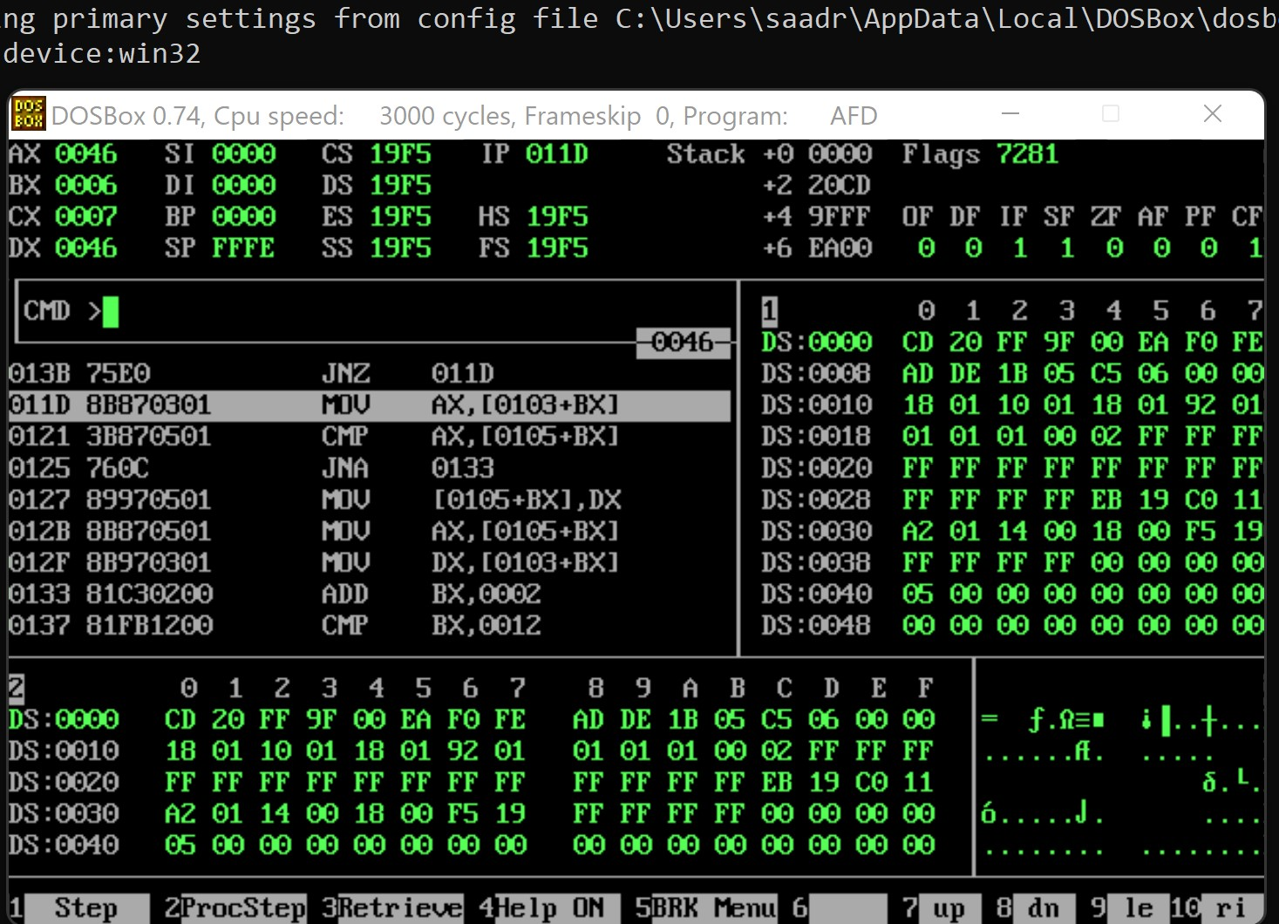

**Qno.2**

[org 0x0100]

jmp start

dataarray: dw -9, 3, -10, -50, 40, -20, 70, -60, 80

start:

mov cx, 10

outerloop:

mov bx,0 ; initialize array index to zero

innerloop:

mov ax,[dataarray+bx]

cmp ax, [dataarray+bx+2]

jbe noswap

mov [dataarray+bx+2], dx

mov ax, [dataarray+bx+2]

mov dx, [dataarray+bx]

noswap:

add bx, 2

cmp bx,18

jne innerloop

sub cx,1

jnz outerloop

mov ax,0x4c00

int 0x21

**Answer**

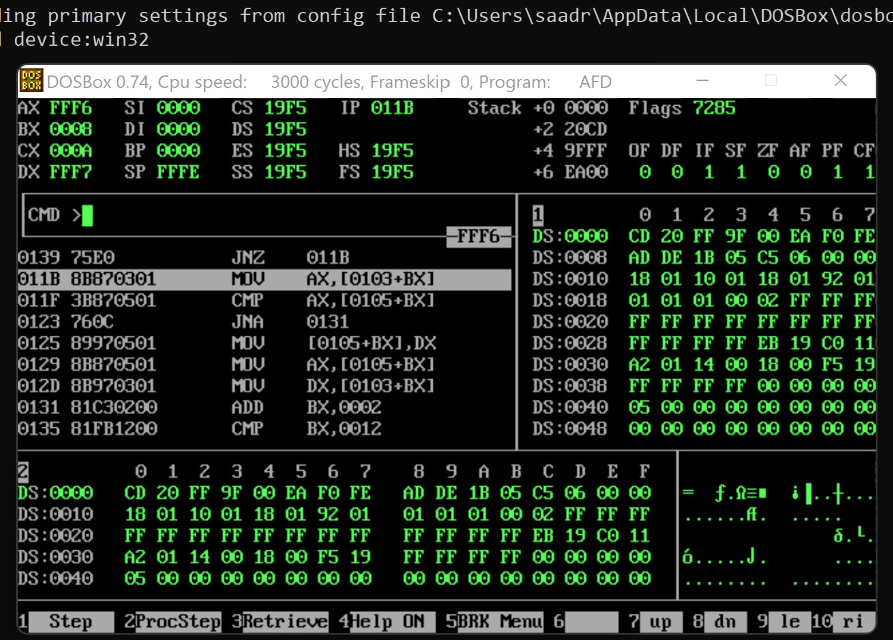

; As carry flag is set, it shows that signed number is carried out.

**Qno.3**

[org 0x0100]

jmp start

dataarray: dw -9, 3, -10, -50, 40, -20, 70, -60, 80

start:

mov cx, 10

outerloop:

mov bx,0 ; initialize array index to zero

innerloop:

mov ax,[dataarray+bx]

cmp ax, [dataarray+bx+2]

jbe noswap

mov dx ,[dataarray+bx+2] ;Below 3 lines are for sorting in ascending order

mov [dataarray+bx+2], ax

mov [dataarray+bx], dx

noswap:

add bx, 2

cmp bx,18

jne innerloop

sub cx,1

jnz outerloop

mov ax,0x4c00

int 0x21

**Answer**

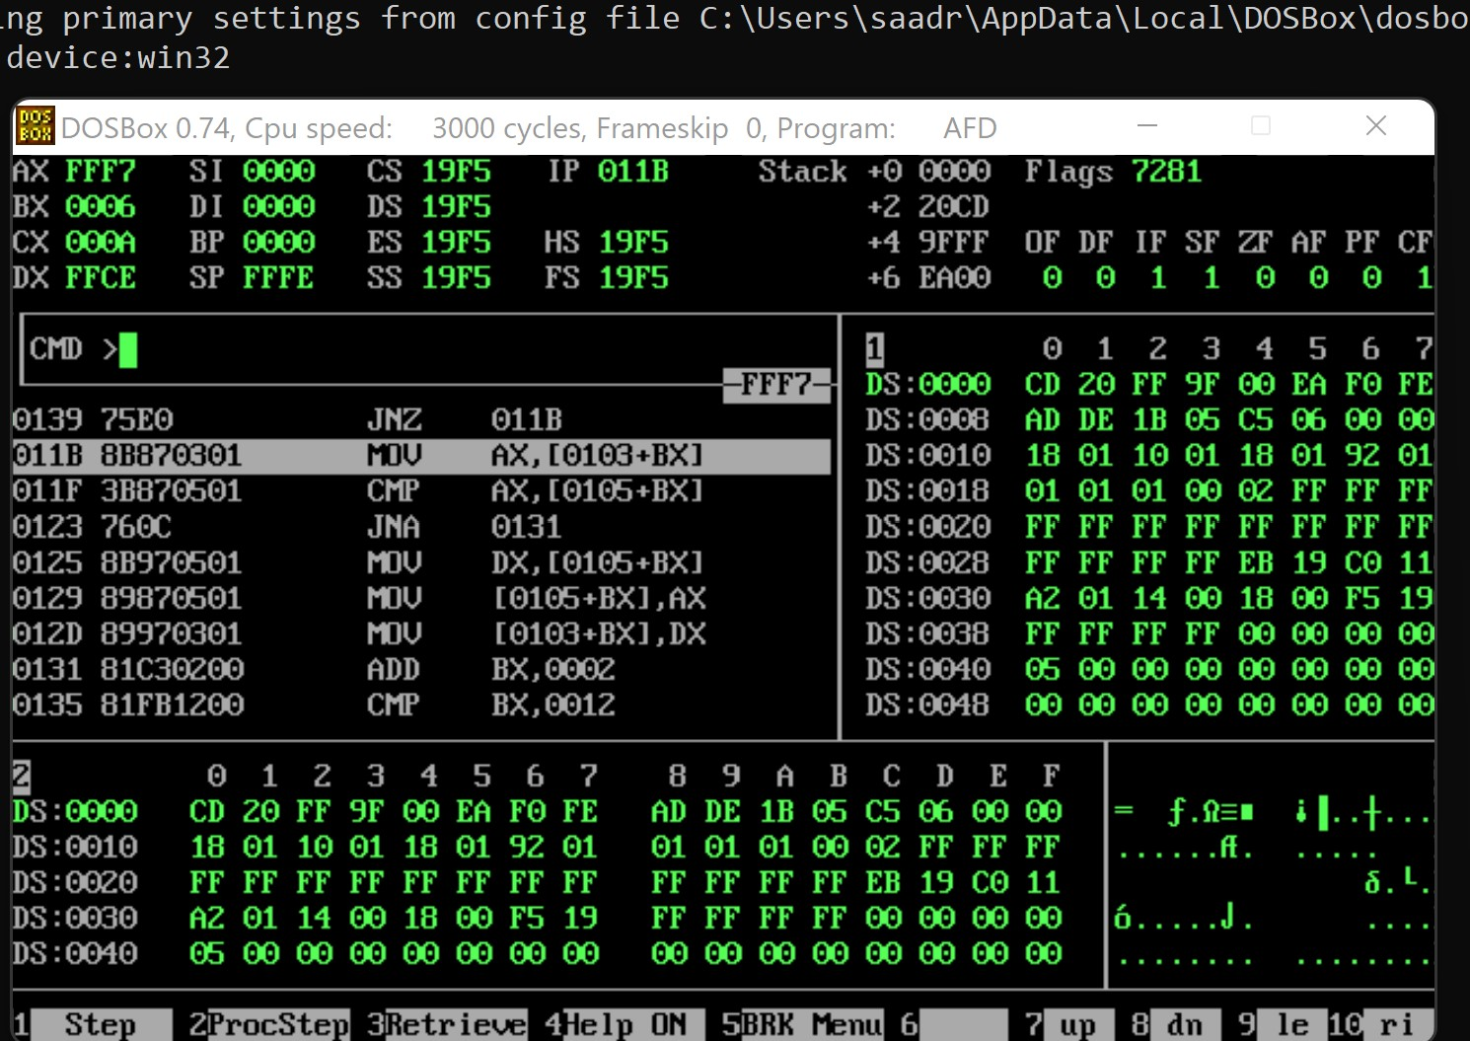

**Qno.4**

[org 0x0100]

jmp start

data: dw 10, 20, -4, 6, 70, -23, -44, 66, 77, 12, -9

s: db 0 ;For signed

us: db 0 ;For unsigned

start:

mov bx,0

mov dx,0

l1:

mov ax,[data+bx]

add bx,2

cmp ax,0

js l1

inc dx ;increment, dx is for counting

cmp bx,18

jne l1 ;Jump to l1 if not equal

mov [us],dx

mov ax,10

sub ax,dx

mov [s],ax

mov ax,0x4c00

int 0x21

**Answer**

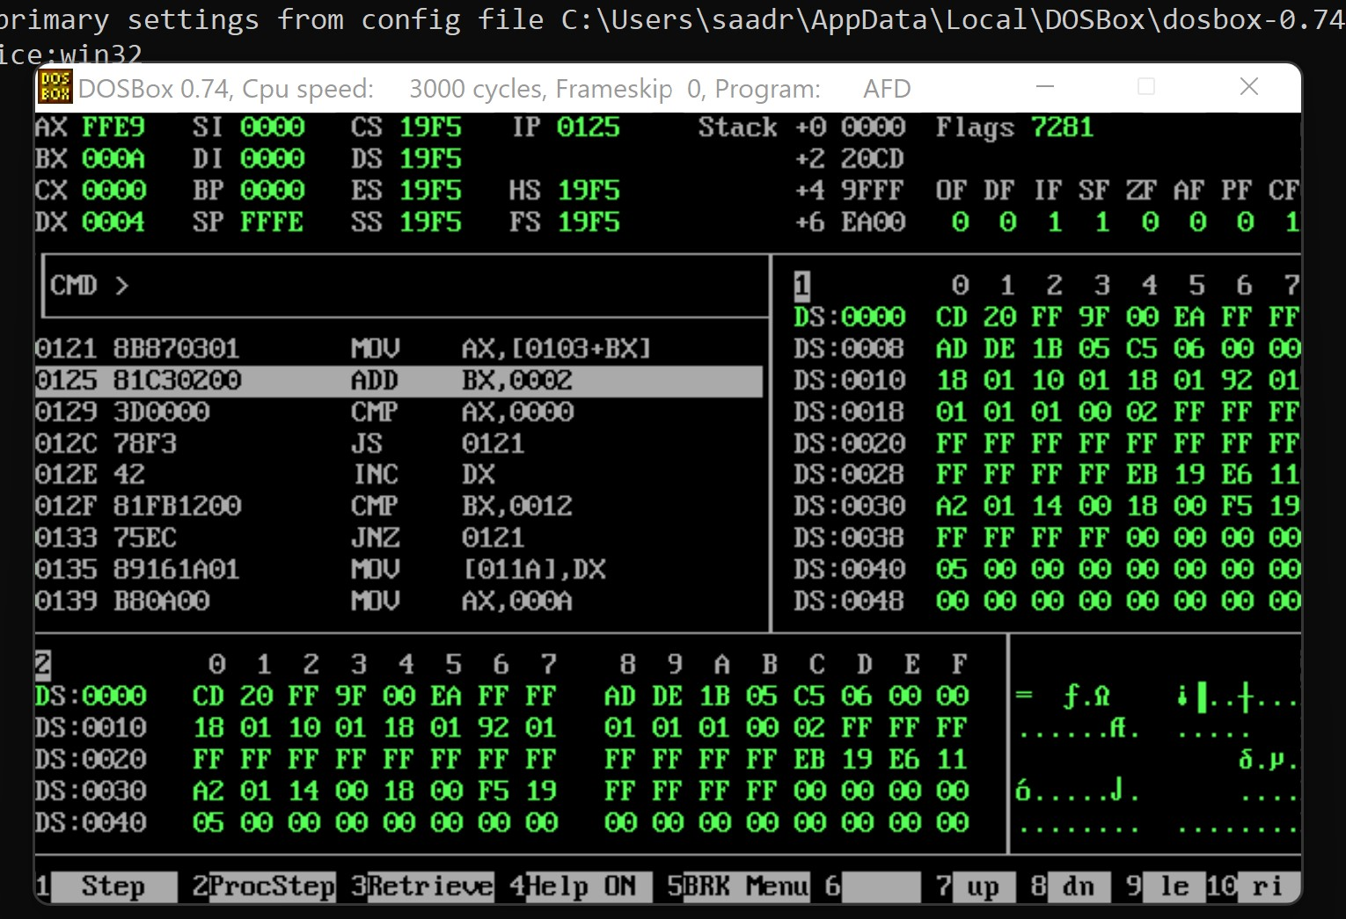

**Qno.5**

[org 0x0100]

jmp start

data: dw 10, 12, 13, 15, 17, 18, 19, 22, 21, 22, 14

start:

loop1:

;mov byte ax,0

mov ax,[data+bx]

add bx, 2

cmp [data+bx], ax

jnz loop1

mov ax,0x4c00

int 0x21

**Answer**

